Contents

Abstract 3

1Introduction 3

2Literature review 3

3Methodology 4

3.1 Data set description and preprocessing 4

3.2 face interest area tracking 4

3.3 feature extraction 4

3.4 heart rate detection 5

3.4.1traditional method(signal process) 5

3.4.2deep learning method (lstm/CNN/Resnet) 6

4 real-time software development 8

5 Results 9

6 Conclusion and suggestions 9

7 Individual parts 9

7.1work division 9

7.2cheng（7-8） 10

7.3li（7-8） 10

7.4yuan（7-8） 10

Acknowledgment 10

Reference 10

Appendices 10

shared part（16-19）

# Abstract

# 1Introduction

1. **research background (ECG PPG introduction)**
2. **( the aims of the project are presented)**
3. **Technical routes & contributions**

# 2Literature review

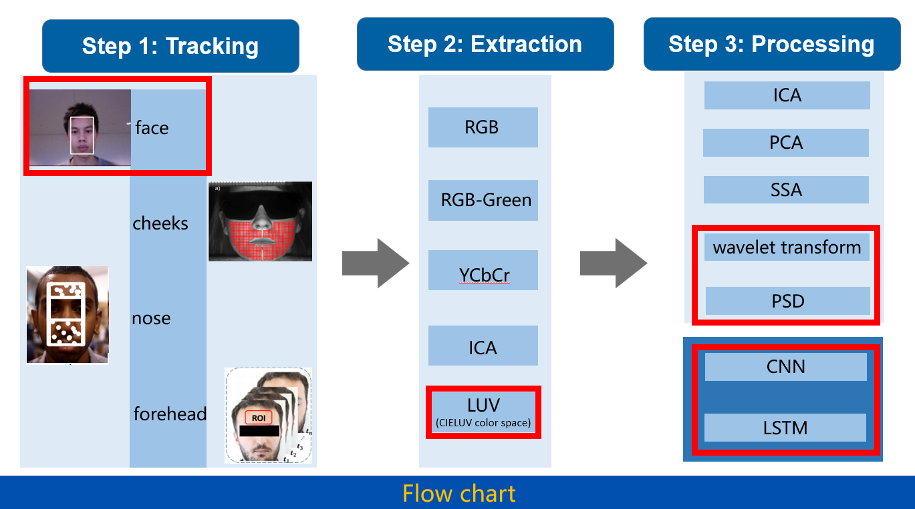

Related work previous

**A.Remote Photoplethysmography Measurement. Step1**

**B.Colour space selection.step2**

**C.Signal processing methods (filter/ machine learning) step3**

# 3Methodology

We used at present

## 3.1 Data set description and preprocessing

Week1.doc

## 3.2 face interest area tracking

**A. Interpretation of code, related toolbox or package**

**How to find AOI**

**b mask to get skin area**

**C.Compare different AOI (cheeks & forehead &nose)**

**Wait for finishing**

## 3.3 feature extraction

**A Different colour space compare (luv, rgb, green)**

**Why select luv**

**B average colour and filter in time serials.**

## 3.4 heart rate detection

### 3.4.1traditional method(signal process)

**Three plans**

**A PSD to find the peak with wavelet filter**

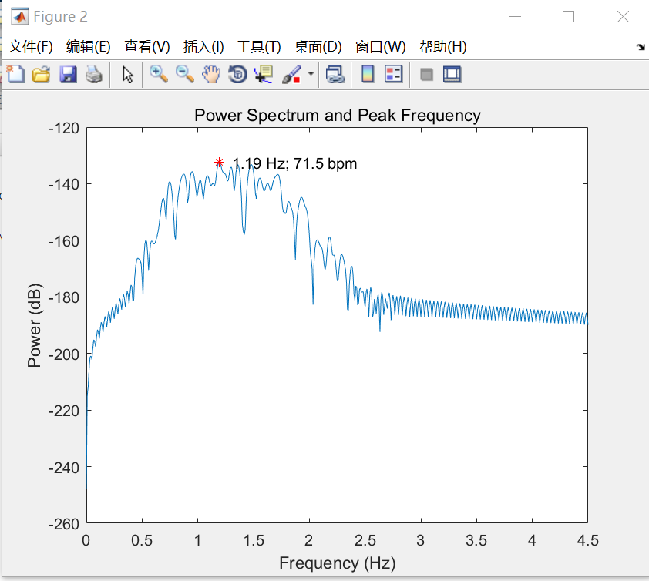

**Results：error= 7.2rpm**

**B singular value decimposition**

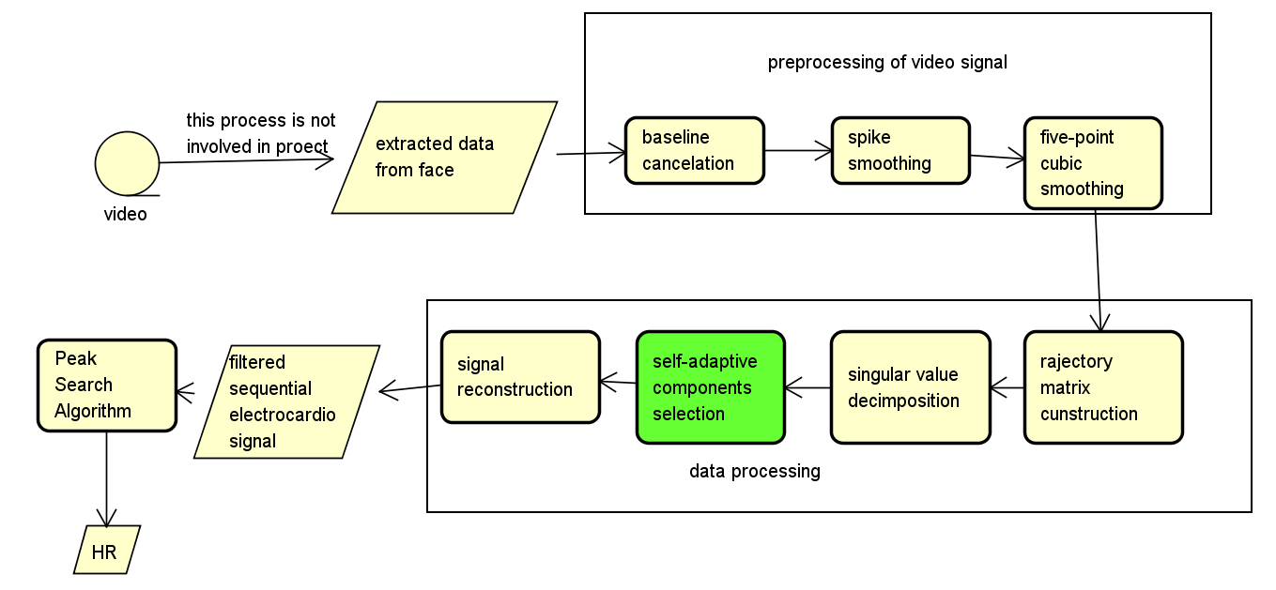

**Results：not stable, but smooth performance better**

**C Integrated method of A &B**

**Results:**

**Error <7.2rpm**

### 3.4.2deep learning method (lstm/CNN/Resnet)

**This part of work based on the work mentioned above.**

**A**

**Method: from paper (cnn+lstm) named CorNET**

**Data processing: Segmentation of signal to 8s**

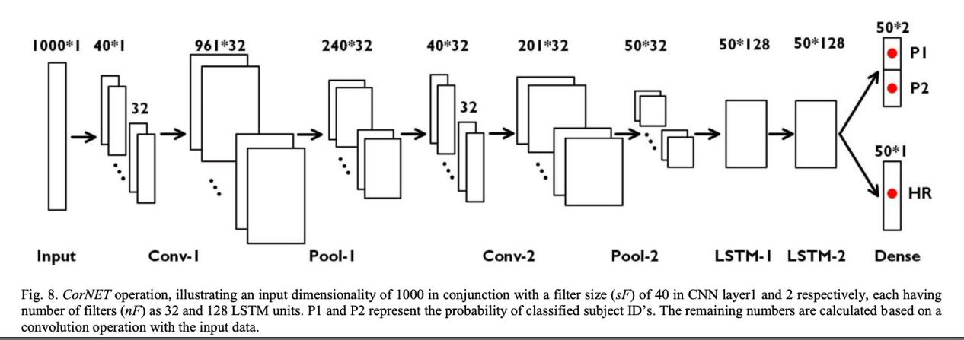

**Results:The results of the training set are excellent, but there is a problem of poor generalisation. Although there is some trend, the results are not good enough.**

**error=**

**B.**

**Method: Multi-Layer CNN architecture**

**Data augmentation --add noise**

**Results: good in good-30s data set (half of the whole date, close to 300),**

**Error=5rpm**

**C 2D-Resnet**

**Wait for finishing**

# 4 real-time software development

Results display：

Video

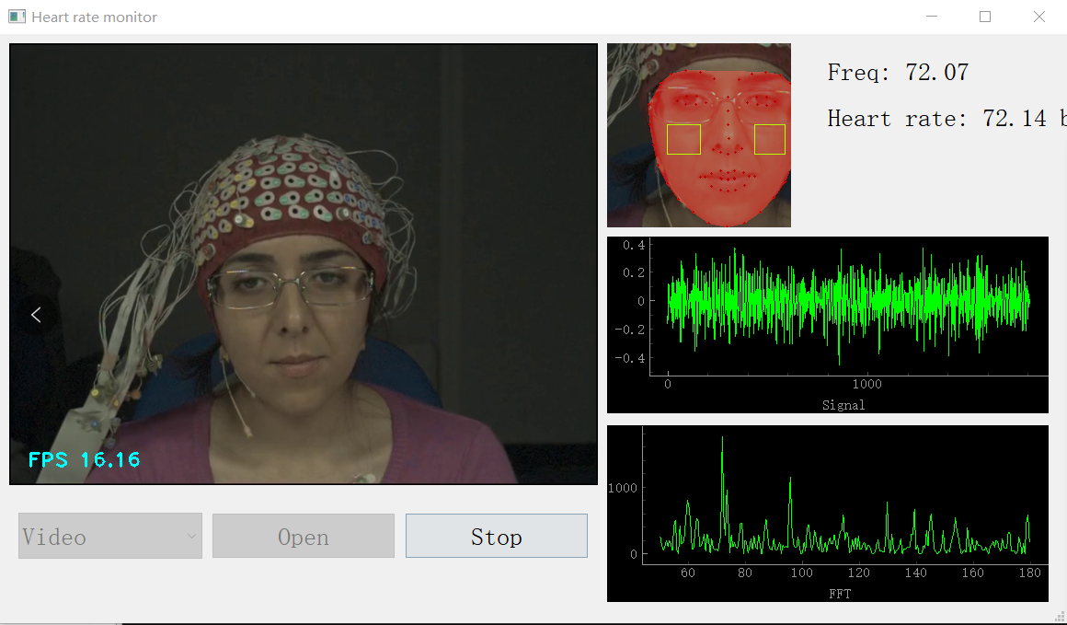

Real-time camera

# 5 Results

1. Signal processing method

Error<7.2rpm

1. Deep learning

1D: error= 5rpm

2D:

1. Real-time software

It works

# 6 Conclusion and suggestions

Conclusion：

1. ROI & colour space
2. Filter method of signal
3. Accuracy rate

Suggestions for further work：

Video enhance method

2D, more methods

# 7 Individual parts

It should be an explanation of technical details in the body of the text, similar to a comment, such as an explanation of the code

## 7.1work division

LiXiang: final results of filtered method in signal processing

Luv & ROI selection

Chenglitao: signal processing part & psd & wavelet

1. D

Yuanxiaoran: 1-D

Software design

## 7.2cheng（7-8）

## 7.3li（7-8）

## 7.4yuan（7-8）

# Acknowledgment

# Reference

# Appendices